Participant Information Sheet

Personal Music Use in Emotional Wellbeing after a Bereavement

You are being invited to take part in a research project. Before you decide, it is important for you to understand why the research is being conducted and what it will involve. Please take the time to read the following information carefully and discuss it with others if you wish. Ask is there is anything that is not clear or if you would like more information. Please take time to decide whether or not you wish to take part.

What is the purpose of the project?
Music is well-known for its emotional impacts and role in regulating emotions. Bereavement and grief can raise a number of complicated emotions, and there is an increasing body of literature which explores music’s role after a bereavement. More research is needed to understand the links between music, emotional wellbeing, and bereavement, and the reasons for these links. Outcomes of this research could be of benefit to organisations supporting people who have experienced a bereavement.

Why have I been chosen?
You have been asked to participate as you have experienced a bereavement 6 months to 2 years ago.

Do I have to take part?
It is up to you to decide whether or not to take part. If you do decide to take part, you will be given this information sheet to keep (and be asked to sign a consent form). You can withdraw at any time during study participation, and up to six months after participating in the study.

What do I have to do? / What will happen to me if I take part?
You will be asked to take part in two one-hour interviews, either in-person or online, three months apart, as well as complete a reflective journal. For the first interview, you will be asked to bring a music-related object to guide the conversation, for example a playlist, photo, instrument, or piece of music. In between these interviews, you will be asked to complete three reflective journal entries guided by a set of prompts. You will be provided with these prompts on a template document on Microsoft Word which you are either welcome to fill out digitally or in a hand-written form. If you want to handwrite your entries, you will be provided with a paper copy of the template and a stamped and addressed envelope to return your reflections. The second interview will take place after you have completed these journal entries and will provide a space for you to expand on topics raised in the first interview and journal entries. Questions will cover what musical activities you have participated in since your bereavement and how they may have made you feel. We will ask broad questions and you are welcome to respond to them in as much depth as you feel able. A diagram explaining the research process can be found on the next page.

Research process:
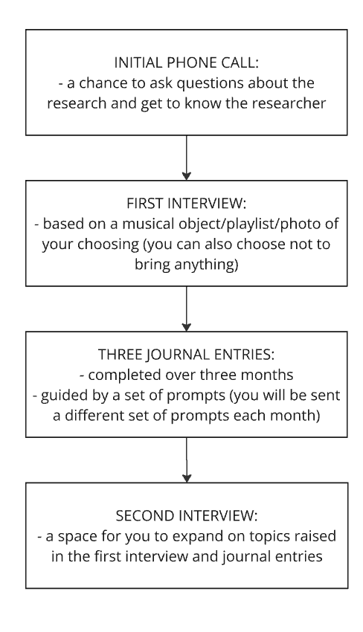
What are the possible disadvantages and risks of taking part?
As the interviews and journal entries will involve the discussion of grief, bereavement, and emotional wellbeing, there is a chance that you may become upset during the course of the research. If this happens during the interview, you will be given the option to pause, discontinue, or reschedule the interview. If it feels too much to participate at any point, there is no obligation to continue with the study. You will be given a list of places to access support in case of emotional distress.
If you have experienced Prolonged (Complicated) Grief Disorder, or any other mental health condition which may affect you during the study, you are encouraged to discuss this with the researcher in the introductory phone call.

What are the possible benefits of taking part?
Whilst there are no immediate benefits for those participating in the project, it is hoped that this work will contribute to the understanding of the role of music after a bereavement. This will help to improve bereavement care services and the experiences of bereaved people.

Use, dissemination and storage of research data
Research data will be stored on a secure data storage platform used by the University of Leeds, called Microsoft OneDrive. Data will be used to better understand the role of music in everyday life after a bereavement. Interview transcripts will be retained until the completion of the researcher’s PhD, and for five years after for publications. Data will be presented at conferences and published in academic journals in an anonymised form, and a version of the research findings will be made available to research participants and organisations who work with bereaved people, again with no personal details shared. If you consent, an anonymised version of your transcripts and journal entries will be made available researchers upon request.

The University of Leeds Research Privacy Notice can be found here: https://dataprotection.leeds.ac.uk/research-participant-privacy-notice/.

What will happen to my personal information?
All the contact information that we collect about you during the research will be kept strictly confidential and will be stored separately from the research data. Research data will be pseudonymised and identifying information (such as names, locations, and the names of charities and organisations) will be removed so that you will not be easily identifiable in any reports or publications. Research data will be stored for the duration of the project and for five years after and may be used for additional or subsequent research by other researchers.

Will I be recorded, and how will the recorded media be used?

The audio and video recordings of the interview made during this research will be transcribed for analysis. No other use will be made of them without your written permission and no one outside the project team (lead researcher and supervisors) will be allowed access to the original recordings.

What will happen to the results of the research project?
The results of the research will form a part of the lead researcher’s doctoral dissertation, and may also be published in journals and presented at conferences. You will not be identified in any report or publication.

Why is the collection of this information relevant for achieving the research project’s objectives?

This information is intended to help bereaved individuals understand how music can help support them after a bereavement; it aims to help bereavement care practitioners understand how to integrate music into their practices and it will help researchers understand the links between music, emotions and grief more fully.
Who is organising/ funding the research?
The research is funded by a Stanley Burton Scholarship at the University of Leeds.

Contact for further information
Elizabeth Fair: mc22eif@leeds.ac.uk
Prof. Alinka Greasley (supervisor): A.E.Greasley@leeds.ac.uk
School of Music, University of Leeds, 12 Cavendish Rd, Woodhouse, Leeds LS2 3AR

Thank you for taking the time to read through this information sheet.
You will be given a copy of this information sheet and a signed consent form to keep if you decide to take part in the research study.

Project title | Document type | Version # | Date
Personal Music Use in Emotional Wellbeing after a Bereavement | Participant Information Sheet | 1 | 20-01-2025

